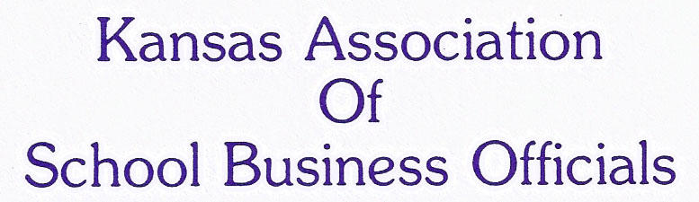
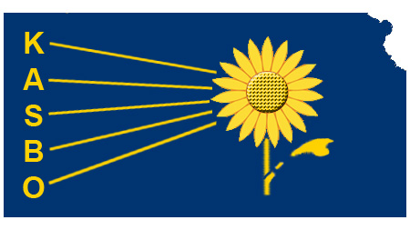

KASBO Board Meeting

January 23, 2015 11:00 a.m. – 1:00 p.m.
Wichita Hyatt

Agenda Items:
- Call to order – Steve Davis, President
- Welcome and Introductions – Steve Davis, President
- Approve Minutes – Vicki Bradley, Secretary
- Approve Treasure Report – Diane Ney, Treasure
- Fall Workshop Update
  - Final Registration Number
  - Feedback about the conference
  - Discuss location for 2015-16
- Convention Committee Report – Steve Davis
  - Conference Theme
  - Discuss the Annual Business Meeting
- Review of Purchases for Annual Convention
  - DJ for Vendor Party
  - Photo Booth
  - Entertainment for April 16, 2015
  - Conference Give Away
- Professional Development Committee Report - Diana Bredehoft
- Scholarship Report – Dan Brungardt
- Annual Audit – Process
- Conference Location 2018
- Executive Director Report – Amy Campbell
- ASBO Leadership Conference
- Strategic Focus Update
  - Legislative Education Program – Jim Freeman
  - Mentoring Program – Dan Brungardt
- USA Update – Dan Brungardt and Jimmy Hay
- Future Meeting Dates:
  - April 14, 2015 Wichita

